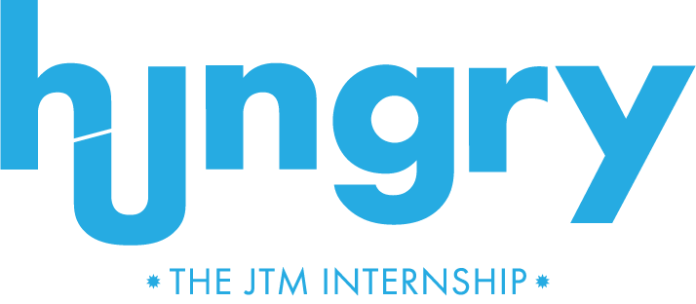

WELCOME TO THE FIRST COURSE
OF YOUR ADVERTISING CAREER.
APPLY NOW THROUGH FEBRUARY 27, 2026.

Our food-focused agency is on the lookout for interns ready to learn about the biz, think with their stomachs and do real work for real clients. If you’re hungry to get your advertising career off the ground, we want to hear from you.

OUR ADVERTISING INTERNSHIP RUNS
JUNE 1 THROUGH JULY 31, 2026.​

++++

APPLY FOR 1 OF 3 ROLES
COPYWRITER
CREATIVE DEPARTMENT
Be the voice of a brand. Use your creativity, ideas and words for writing social posts, digital ads, brand campaigns, sales materials and blog content. Grammatical excellence is non-negotiable, but Oxford commas are up for debate.

ART DIRECTOR
CREATIVE DEPARTMENT
Calling visual communicators. In this role, you’ll translate words, ideas and concepts into beautiful works of advertising art that demand attention. Knowledge of Adobe Creative Suite needed, along with occasional willingness to make the logo bigger.

ACCOUNT SERVICE
ACCOUNT SERVICES DEPARTMENT
Help support clients and internal teams by assisting with project timelines, status calls, creative briefs, meeting notes and more. If you like wearing many hats, can multitask and have the ability to talk about bacon, pizza or burgers without drooling, we want you.

PLEASE APPLY FOR ONE POSITION ONLY
Why? Our goal is to help you become the best writer or art director or account executive you can be.

++++

HOW TO APPLY
All applications must include the following:
-NAME, ADDRESS + CELL NUMBER
-THE POSITION YOU WANT
-CURRENT RESUME

PLUS ONE FROM BELOW:

A COVER LETTER
(being unconventional is strongly encouraged)

A VIDEO
of you reviewing a fast-food restaurant
AN ESSAY
that answers “if you could be any vegetable, what would it be and why?”

ORIGINAL LYRICS
that are an ode to your favorite beverage

A RECIPE
that describes you

A FOOD-FOCUSED
way to show us why you’re the best candidate

ALL CREATIVES MUST SUBMIT ONE OF THE FOLLOWING:
Relevant examples of your creative skills
Advertising portfolio

++++

QUESTIONS?
All submissions and questions must be sent to:
hungryintern@jtmega.com.



JT Mega is committed to creating a diverse, safe and welcoming workplace with opportunity for all. We strive for inclusion, equity and diversity in both our words and actions. BIPOC, women, marginalized communities, LGBTQIA+, veterans and persons with disabilities are encouraged to apply.

